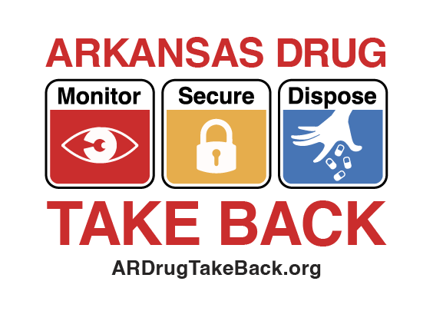
FOR IMMEDIATE RELEASE
Contact:
Local Contact Name
Phone Number
Email address

Arkansas Opioid Recovery Partnership encourages Arkansans
to participate in Arkansas Drug Take Back initiatives
ReviveAR app serves as resource for Drug Take Back locations and information

[City], Ark. ([Month, Day], 2026) — The Arkansas Opioid Recovery Partnership (ARORP) encourages Arkansans to monitor, secure and dispose of unused and expired prescription medications by downloading the ReviveAR app and learning more about Arkansas Drug Take Back, which provides information about how individuals can safely dispose of medications they no longer need.

Arkansans are encouraged to place prescription medications in a safe, locked container and dispose of their unneeded prescriptions at a collection site near them. ReviveAR, available on the Apple and Google Play stores, contains various Drug Take Back resources, including a search function to find drop off locations by name, ZIP code and distance.

“More than half of people who misuse prescription medications obtain them from family and friends,” said [name, title, organization]. “Disposing of unused medications is an easy, proactive way to safeguard our communities and foster a healthier future for all Arkansans.”

To date, Arkansas Drug Take Back has safely destroyed 658,206 pounds of medication, 28,754 pounds of which was disposed of in spring 2025. For more information about Arkansas Drug Take Back, visit ARDrugTakeBack.org. For more information about ARORP or ReviveAR, visit ARORP.org.

About the Arkansas Opioid Recovery Partnership
The Arkansas Opioid Recovery Partnership (ARORP), an initiative of the Arkansas Municipal League and the Association of Arkansas Counties, represents an unprecedented united front between the representatives of local government to abate the loss of life caused by the opioid epidemic in Arkansas communities. The Partnership oversees the strategic disbursement of opioid settlement dollars at the city and county levels and works to reduce overdose deaths through prevention, treatment, enforcement and recovery. ARORP’s message is simple: be bold, stand together and commit to abating opioid misuse and addiction in Arkansas. To learn more and submit a request for funding, visit ARORP.org.

###

